Tool Calling in LangChain
https://colab.research.google.com/drive/1-xMYU9ExZqoySEX-XHAvEaE17PCWvc9H?usp=sharing
https://www.youtube.com/watch?v=EzYaFF7ahKw&list=PLKnIA16_RmvaTbihpo4MtzVm4XOQa0ER0&index=19
00:00 - Intro 01:06 - Quick Revision 05:18 - Tool Binding 11:43 - Tool Calling 19:17 - Tool Execution 28:44 - Currency Conversion Tool 56:28 - Is this an AI Agent?
LangChain Tool Calling
Introduction
In this video, we continue the LangChain Agents playlist. In the previous video, we started the journey of building AI agents step by step and introduced a very important concept called Tools.
This video builds directly on that foundation and introduces another core concept required to create real-world AI agents: Tool Calling.
By the end of this video, you will understand:
- Why tools are required for AI agents
- How tools are connected to an LLM (Tool Binding)
- How an LLM decides when to use a tool (Tool Calling)
- Who actually executes the tool and why
This concept is extremely important because almost every practical AI agent relies on tool calling.

Quick Revision: What LLMs Can and Cannot Do
Large Language Models (LLMs) have two major strengths:
1. Reasoning
LLMs can analyze a question, break it down, and understand what is being asked.
2. Output Generation
Based on the question, LLMs use their parametric knowledge to generate a relevant text-based response.
Because of these abilities, you can think of an LLM as a human who:
- Can think well
- Can speak well
The Core Limitation of LLMs
Despite their intelligence, LLMs cannot perform actions on their own. For example, an LLM cannot:
- Update your database
- Post on LinkedIn or Twitter
- Call an external API
- Fetch real-time weather data
Using a human analogy:
LLMs can think and talk, but they have no hands or legs to perform tasks.
This is a serious limitation if we want LLMs to act as powerful software agents.

Tools: Giving Hands and Legs to LLMs
To solve this limitation, we introduce Tools.
A tool is a function that:
- Performs a specific task
- Can be used by an LLM when required
Examples discussed earlier:
- DuckDuckGo Search Tool – searches the web
- Shell Tool – runs command-line commands
- Custom tools – created by you for your own use cases
Technically, tools are just special Python functions that are designed to interact with LLMs.
In the previous video, we learned:
- What built-in tools are
- What custom tools are
- What toolkits are
However, one important question remained unanswered:
How do we connect tools with an LLM, and how does an LLM decide when to use them?
That is exactly what this video covers.

Tool Binding
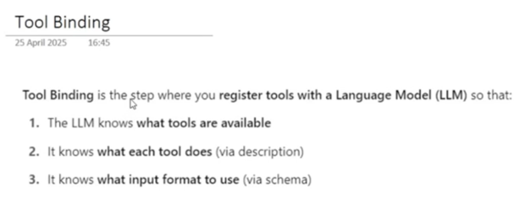
What Is Tool Binding?
Tool binding is the process of connecting (or registering) tools with an LLM.
Once tools are bound:
- The LLM knows which tools are available
- The LLM knows what each tool does
- The LLM knows what input format each tool expects
In simple terms:
Tool binding teaches the LLM how it can use tools.

Why Tool Binding Is Required
When creating a tool, we define:
- Tool name
- Tool description
- Tool input schema
Tool binding transfers this information to the LLM so that it can:
- Decide when a tool is useful
- Generate correct inputs for that tool
Without tool binding, the LLM has no idea that a tool even exists.

Example: Creating a Simple Tool
To understand the concept clearly, a simple multiplication tool is used.
Conceptually, this tool:
- Takes two integers: A and B
- Returns their product
Once created, the tool behaves like a runnable object:
- It can be invoked directly
- It exposes metadata such as:
  - name
  - description
  - args_schema
This metadata is exactly what the LLM consumes during tool binding.
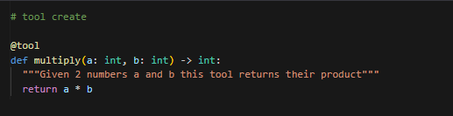

Binding the Tool with an LLM
To bind tools with an LLM:
- Create an LLM instance (for example, ChatOpenAI)

- Use the bind_tools() method

- Pass a list of tools to be registered
After binding:
- The result must be stored in a new variable
- The original LLM remains unchanged
The new LLM instance:
- Is still an LLM
- But now has access to the registered tools
From this point onward, the LLM can suggest using these tools whenever required.
Important: Not all LLMs support tool binding. Only specific models can work with tools.

Tool Calling
What Is Tool Calling?
Tool calling is the process where the LLM:
- Analyzes the user query
- Decides that a tool is required
- Generates a structured output describing:
  - Which tool to use
  - What input arguments to pass
Formally:
Tool calling is the process where an LLM decides during a conversation that a specific tool is needed and outputs the tool name along with its arguments in a structured format.

Tool Calling vs Normal Responses
Consider two scenarios:
Scenario 1: Normal Question
User: Hi, how are you?
The LLM knows it can answer this directly. No tool is required, so it returns a normal text response.
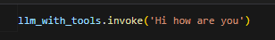
Scenario 2: Tool-Required Question
User: Can you multiply 3 with 10?
Now the LLM:
- Checks available tools
- Finds the multiply tool
- Generates a structured tool call instead of plain text
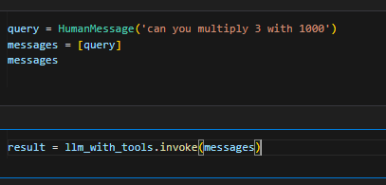

What Does a Tool Call Look Like?
A tool call contains:
- Tool name (e.g., multiply)
- Input arguments (e.g., A = 3, B = 10)
- A unique tool call ID
- Type information
Multiple tool calls can exist, but in this example, only one tool call is generated.
This structured output is the key result of tool calling.

Very Important Clarification: Who Executes the Tool?
This is where most beginners get confused.
❌ What Does NOT Happen
- The LLM does NOT execute the tool
- The LLM does NOT call APIs
- The LLM does NOT fetch results
✅ What Actually Happens
- The LLM only suggests the tool
- The LLM provides the exact input arguments
- The developer or LangChain runtime executes the tool
In short:
The LLM decides what should be done. Your code decides how it is executed.

Why LLMs Should Not Execute Tools
Allowing LLMs to execute tools directly would be risky:
- LLMs can make incorrect decisions
- Wrong tools could be executed
- Sensitive operations could be triggered accidentally
Therefore, control always remains with the developer.
The LLM acts as an advisor, not an executor.

Tool Execution
So far, we have learned three powerful concepts:
- Tool Creation
- Tool Binding
- Tool Calling
Now we arrive at the fourth and most interesting piece of the puzzle: Tool Execution.
Tool execution is where things finally move from decision to action.

What Is Tool Execution?
Once the LLM suggests:
- Which tool should be used
- What input arguments should be passed
…it becomes the developer’s responsibility to actually run that tool.
Formally:
Tool execution is the step where the actual Python function (tool) is executed using the input arguments suggested by the LLM during tool calling.
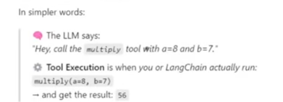

Conceptual Flow
The flow looks like this:
- User asks a question
- LLM analyzes the query
- LLM generates a tool call (tool name + arguments)
- Developer executes the tool using those arguments
- Tool returns a result
This entire step (4 → 5) is called Tool Execution.

Executing the Tool Using Tool Call Output
At this point, we already have a tool call object generated by the LLM.
From that tool call, we extract:
- The tool name
- The input arguments (args)
Below is how tool call looks like
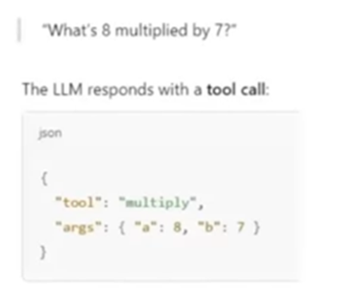
These arguments are then passed to the tool’s invoke() method.
Once executed, the tool returns the expected result.
This confirms an important idea:
The LLM suggests the inputs, but the programmer controls execution.

Executing Only Arguments vs Full Tool Call
There are two ways to execute a tool:
1. Passing Only Arguments
If you pass only the args dictionary to the tool:
- The tool executes
- You receive the raw output (for example, 30)
This is useful when you only care about the result.
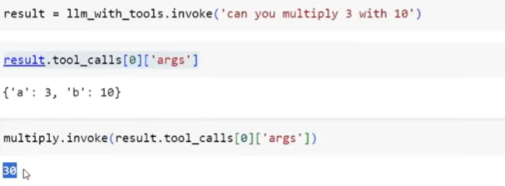

2. Passing the Entire Tool Call
If you pass the entire tool call object:
- The tool executes successfully
- The output is wrapped inside a Tool Message
This Tool Message contains:
- Tool name
- Tool call ID
- Tool output
This approach is preferred when you want to continue the conversation with the LLM.
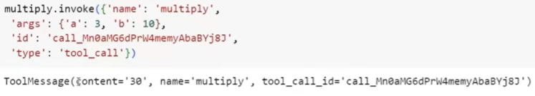

Tool Message: A New Message Type
Earlier, we learned about:
- HumanMessage
- AIMessage
- SystemMessage
ToolMessage is another important message type.
A ToolMessage is generated:
- When a tool is executed
- Using a tool call produced by the LLM

Why Tool Messages Are Important
The biggest advantage of a ToolMessage is:
It can be sent back to the LLM as part of the conversation history.
This allows the LLM to:
- See the tool execution result
- Use that result to generate a final, user-friendly response

Maintaining Conversation History
To complete the agent loop, we maintain a messages list:
- HumanMessage – the original user query
- AIMessage – the LLM response containing the tool call
- ToolMessage – the result of tool execution
This list represents the full conversation so far.

Sending Context Back to the LLM
Once all messages are collected:
- The full message history is sent back to the LLM
- The LLM now has complete context
With this context, the LLM can generate a final natural-language answer.
Example final response:
“The product of 3 and 10 is 30.”


Common Beginner Mistake (Important)
A frequent mistake is:
- Sending a hardcoded query to the LLM
- Instead of sending the messages list
Correct behavior:
- Always pass the updated messages list
- So the LLM sees the entire conversation flow
This ensures correct and consistent answers.

Complete Agent Flow Summary
From top to bottom, the full flow is:
- Tool Creation
- Tool Binding
- Tool Calling
- Tool Execution
- Context aggregation (Human → AI → Tool messages)
- Final LLM response
This is the core loop behind AI agents.

Why This Step Matters
What you have learned here is not just theory.
This is:
- The first solid step toward building AI agents
- The foundation for real-world applications
- A safe and controlled way to combine LLM intelligence with external systems
Once this makes sense, everything ahead—agents, workflows, automation—will feel natural.

What Comes Next
After this, we move toward:
- Building a meaningful application
- Using real APIs (e.g., currency conversion)
- Designing full agent pipelines
This is where LangChain truly shines.

Currency Conversion Tool – LangChain Tool Execution
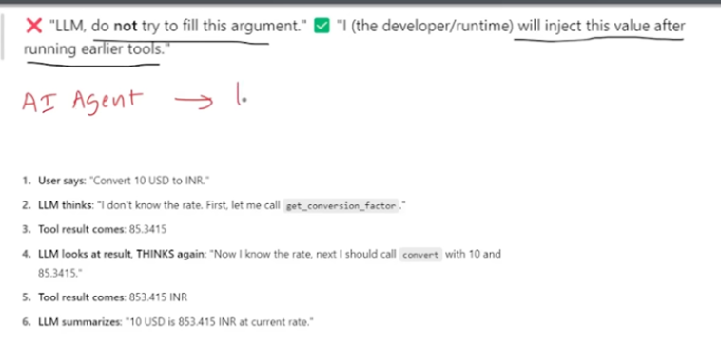
1. Problem Statement
LLMs do not have real-time currency exchange rates. If you ask:
Convert 80 USD to INR
The LLM may answer using old / historical data, which is incorrect for real-world use.
Solution
We solve this by connecting the LLM to external tools that can:
- Fetch real-time currency conversion rates from an API
- Use that rate to calculate the converted amount
This is a practical example of Tool Calling + Tool Execution in LangChain.

2. High-Level Architecture
We build two tools:
Tool 1: Get Conversion Factor
- Calls a real-time Exchange Rate API
- Fetches conversion rate between two currencies (e.g., USD → INR)
Tool 2: Convert Currency
- Takes:
  - Base currency value (e.g., 10 USD)
  - Conversion rate (e.g., 85.34)
- Returns converted value (e.g., 853.4 INR)
The workflow is:
User Query → LLM → Tool 1 → Tool 2 → Final Answer

3. Tool 1: Get Conversion Factor
Purpose
Fetches the real-time conversion rate between two currencies.
Inputs
- base_currency (string) → e.g., "USD"
- target_currency (string) → e.g., "INR"
Output
- A JSON response containing:
  - Conversion rate
  - Last updated timestamp
Description
This function fetches the currency conversion factor between a given base currency and a target currency.
API Used
Exchange Rate API (requires API key)
The API dynamically returns the latest conversion rate, which may change every minute.

4. Tool 2: Convert Currency
Purpose
Calculates the converted value using a given conversion rate.
Inputs
- base_currency_value (integer / float)
- conversion_rate (float)
Output
- Converted currency value (float)
Description
Given a currency conversion rate, this function calculates the target currency value from a given base currency value.
Formula Used
converted_value = base_currency_value × conversion_rate

5. Tool Binding with LLM
Both tools are bound to the LLM using:
- llm.bind_tools([get_conversion_factor, convert])
This allows the LLM to:
- Decide which tool to call
- Decide what inputs to send

6. Tool Calling Issue (Important Concept)
User Query Example
What is the conversion factor between USD and INR, and convert 10 USD to INR
What Went Wrong?
The LLM tried to call both tools at once:
- Correctly called get_conversion_factor
- Incorrectly called convert with a guessed conversion rate from training data
This happened because:
- The real conversion rate was not yet available at tool-calling time
- The LLM filled missing values using parametric knowledge
This broke our logic.

7. Solution: Injected Tool Arguments
Concept
Injected Tool Arguments allow the developer to supply certain tool inputs after tool execution, not during tool calling.
What We Did
- Marked conversion_rate as an InjectedToolArgument
- Told the LLM:
Do NOT fill this value. I will inject it manually.
Result
- LLM calls convert with only base_currency_value
- Conversion rate is injected later from Tool 1’s output

8. Tool Execution Flow (Step-by-Step)
Step 1: Human Message
User asks for currency conversion.
Step 2: AI Message
LLM returns two tool calls:
- get_conversion_factor
- convert (without conversion_rate)
Step 3: Execute Tool 1
- Call get_conversion_factor
- Receive Tool Message with real-time rate
- Extract conversion rate from JSON
Step 4: Inject Argument
- Add extracted conversion rate into Tool 2 arguments
Step 5: Execute Tool 2
- Call convert using injected conversion rate
Step 6: Store Messages
Messages list now contains:
- Human Message
- AI Message
- Tool Message (conversion factor)
- Tool Message (final calculation)

9. Final LLM Call
The entire message history is sent back to the LLM.
Output Example
The conversion factor between USD and INR is 85.34. Based on this rate, converting 10 USD results in 853.4 INR.
The answer is:
- Accurate
- Real-time
- Explainable

10. Is This an AI Agent?
Short Answer: ❌ No
Why?
An AI Agent must be autonomous.
In this application:
- The developer manually:
  - Executes tools
  - Injects arguments
  - Controls execution order
What an Agent Would Do
An agent would:
- Break the problem into steps
- Decide tool execution order
- Pass outputs between tools
- Produce the final answer without manual control
That autonomy is missing here.

11. Key Takeaways
- LLMs need tools for real-time data
- Tool Calling ≠ Tool Execution
- Injected Tool Arguments prevent hallucinated inputs
- This pattern is a foundation for AI Agents

